Web Application of caBench-to Bedside v 3.0
End User Manual

Document Change History
Version Number | Date | Contributor | Description
V3.0 | May 10, 2009 | Washington University/Persistent Systems Ltd/National cancer Institute | Reviewed
V3.0 | July31,2009 | Washington University/Persistent Systems Ltd/National cancer Institute | Addressed comments by Documentation and Training Workspace



This is a U.S. Government work. August 11, 2009

Copyright and License Information
Copyright Notice. Copyright 2005 “School of Medicine, Washington University in St. Louis” (“caBIG® Participant”). cancer Bench-to-Bedside was created with NCI funding and is part of the caBIG® initiative. The software subject to this notice and license includes both human readable source code form and machine readable, binary, object code form (the “caBIG® Software”).
This caBIG® Software License (the “License”) is between caBIG® Participant and You. “You (or “Your”) shall mean a person or an entity, and all other entities that control, are controlled by, or are under common control with the entity. “Control” for purposes of this definition means (i) the direct or indirect power to cause the direction or management of such entity, whether by contract or otherwise, or (ii) ownership of fifty percent (50%) or more of the outstanding shares, or (iii) beneficial ownership of such entity.
License. Provided that You agree to the conditions described below, caBIG® Participant grants You a non-exclusive, worldwide, perpetual, fully-paid-up, no-charge, irrevocable, transferable and royalty-free right and license in its rights in the caBIG® Software, including any copyright or patent rights therein that may be infringed by the making, using, selling, offering for sale, or importing of caBIG® Software, to (i) use, install, access, operate, execute, reproduce, copy, modify, translate, market, publicly display, publicly perform, and prepare derivative works of the caBIG® Software; (ii) make, have made, use, practice, sell, and offer for sale, and/or otherwise dispose of caBIG® Software (or portions thereof); (iii) distribute and have distributed to and by third parties the caBIG® Software and any modifications and derivative works thereof; and (iv) sublicense the foregoing rights set out in (i), (ii) and (iii) to third parties, including the right to license such rights to further third parties. For sake of clarity, and not by way of limitation, caBIG® Participant shall have no right of accounting or right of payment from You or Your sublicensees for the rights granted under this License. This License is granted at no charge to You. Your downloading, copying, modifying, displaying, distributing or use of caBIG® Software constitutes acceptance of all of the terms and conditions of this Agreement. If you do not agree to such terms and conditions, you have no right to download, copy, modify, display, distribute or use the caBIG® Software.
- Your redistributions of the source code for the caBIG® Software must retain the above copyright notice, this list of conditions and the disclaimer and limitation of liability of Article 6 below. Your redistributions in object code form must reproduce the above copyright notice, this list of conditions and the disclaimer of Article 6 in the documentation and/or other materials provided with the distribution, if any.
- Your end-user documentation included with the redistribution, if any, must include the following acknowledgment: “This product includes software developed by School of Medicine, Washington University in St. Louis.” If You do not include such end-user documentation, You shall include this acknowledgment in the caBIG® Software itself, wherever such third-party acknowledgments normally appear.
- You may not use the names “School of Medicine, Washington University in St. Louis”, “The National Cancer Institute”, “NCI”, “Cancer Bioinformatics Grid” or “caBIG®” to endorse or promote products derived from this caBIG® Software. This License does not authorize You to use any trademarks, service marks, trade names, logos or product names of either caBIG® Participant, NCI or caBIG®, except as required to comply with the terms of this License.
- For sake of clarity, and not by way of limitation, You may incorporate this caBIG® Software into Your proprietary programs and into any third party proprietary programs. However, if You incorporate the caBIG® Software into third party proprietary programs, You agree that You are solely responsible for obtaining any permission from such third parties required to incorporate the caBIG® Software into such third party proprietary programs and for informing Your sublicensees, including without limitation Your end-users, of their obligation to secure any required permissions from such third parties before incorporating the caBIG® Software into such third party proprietary software programs. In the event that You fail to obtain such permissions, You agree to indemnify caBIG® Participant for any claims against caBIG® Participant by such third parties, except to the extent prohibited by law, resulting from Your failure to obtain such permissions.
- For sake of clarity, and not by way of limitation, You may add Your own copyright statement to Your modifications and to the derivative works, and You may provide additional or different license terms and conditions in Your sublicenses of modifications of the caBIG® Software, or any derivative works of the caBIG® Software as a whole, provided Your use, reproduction, and distribution of the Work otherwise complies with the conditions stated in this License.
- THIS caBIG® SOFTWARE IS PROVIDED "AS IS" AND ANY EXPRESSED OR IMPLIED WARRANTIES (INCLUDING, BUT NOT LIMITED TO, THE IMPLIED WARRANTIES OF MERCHANTABILITY, NON-INFRINGEMENT AND FITNESS FOR A PARTICULAR PURPOSE) ARE DISCLAIMED. IN NO EVENT SHALL THE SCHOOL OF MEDICINE, WASHINGTON UNIVERSITY IN ST. LOUIS OR ITS AFFILIATES BE LIABLE FOR ANY DIRECT, INDIRECT, INCIDENTAL, SPECIAL, EXEMPLARY, OR CONSEQUENTIAL DAMAGES (INCLUDING, BUT NOT LIMITED TO, PROCUREMENT OF SUBSTITUTE GOODS OR SERVICES; LOSS OF USE, DATA, OR PROFITS; OR BUSINESS INTERRUPTION) HOWEVER CAUSED AND ON ANY THEORY OF LIABILITY, WHETHER IN CONTRACT, STRICT LIABILITY, OR TORT (INCLUDING NEGLIGENCE OR OTHERWISE) ARISING IN ANY WAY OUT OF THE USE OF THIS caBIG® SOFTWARE, EVEN IF ADVISED OF THE POSSIBILITY OF SUCH DAMAGE.

.

Insert Names of Development Team(s) here
Development | User’s Guide | Program Management
Chandrakant Talele¹ | Chandrakant Talele¹ | Rakesh Nagarajan²
Chetan Patil¹ | Madhumita Shrikhande¹ | Srikanth Adiga^{2,1}
Chetan Pundhir¹ | Pooja Arora¹ | Chandrakant Talele¹
Deepak Shingan¹ | Mukesh Sharma² | Mukesh Sharma²
Gaurav Mehta¹ | Chris Piepenbring ⁴ | Stephen A. Goldstein³
Rajesh Vyas¹ | Stephen A. Goldstein³
- Persistent Systems Limited | - Washington University
- Sapient Corporation | - Capability Plus Solutions

Contacts and Support
Training contact | cab2bsupport@bmi.wustl.edu
Customer support contact | cab2bsupport@bmi.wustl.edu

Contents

About This Guide 1
Purpose 1
Typical User 1
Topics Covered 1
Text Conventions Used 2
Chapter 1 Introduction 3
Conducting Research using caB2B Web Application 3
Getting started with caB2B 4
Secure and Non-Secure Data 4
Starting caB2B Web Application 5
Home Page 5
Types of User 7
Understanding Queries and Limits 7
What is a Limit? 7
What is a Query? 8
Application Workflow 8
How caB2B Web Application differs from caB2B Client Application? 8
Chapter 2 Databases to Search 11
Introduction 11
Configuring Hosting Institutions 11
Chapter 3 Keyword Search 15
Introduction 15
Search Data 15
View Results 16
Export Results 17
Chapter 4 Saved Searches 19
Define Limits 19
View search Results 21
Export Results 22
Chapter 5 Error Messages/Indicators and Problem Resolutions 23
Access secure data 23
Invalid login credentials 24
Failed Hosting Institutions 25
Appendix A Example for searching data 27
Keyword Search 27
Saved Searches 31
Index 35

About This Guide
This section introduces you to the caBench-To-Bedside V 3.0. Topics in this section include
- Purpose
- Typical User
- Topics Covered
- Text Conventions Used

Purpose
This manual provides the details of how to use cancer Bench-to-Bedside (caB2B) Web Application to search data (for example, Biospecimen data, Microarray data, etc.) available on the cancer Biomedical Informatics Grid (caBIG®). The user can search data using keyword or detailed saved search. The user can export and save the retrieved data for further experimentation work or analysis.

Typical User
This guide is designed for translational research scientist. The term translational research means research which typically begins at “the bench” with basic research — in which scientists study disease at a molecular or cellular level — then progress to the clinical level, or the patient's “bedside.”
No special knowledge or skill is required to use the caB2B web application.

Topics Covered
If you are new to caB2B Web Application, read this brief overview, which explains what you will find in each chapter and appendix.
- “Chapter 1 Introduction” describes the scope and function of caB2B Web Application.
- “Chapter 2 Databases to Search” describes process of configuring service instances for query
- “Chapter 3 Keyword Search” describes the process of searching metadata based on keyword.
- “Chapter 4 Saved Searches” describes the process of searching metadata based on detailed saved searches.
- “Chapter 5 Error Messages/Indicators and Problem Resolutions” describes the various error messages and troubleshooting options.
- “Appendix A: Example for searching data” describes an example query that can be executed using the caB2B Web Application.

Text Conventions Used
This section explains conventions used in this guide. The various typefaces represent interface components, keyboard shortcuts, toolbar buttons, dialog box options, and text that you type.
Convention | Description | Example
Bold | Highlights names of option buttons, check boxes, drop-down menus, menu commands, command buttons, or icons. | Click Search.
URL | Indicates a Web address. | http://domain.com
text in Small Caps | Indicates a keyboard shortcut. | Press Enter.
text in Small Caps + text in Small Caps | Indicates keys that are pressed simultaneously. | Press Shift + Ctrl.
Italics | Highlights references to other documents, sections, figures, and tables. | See Figure 4.5.
Italic boldface monospace type | Represents text that you type. | In the New Subset text box, enter Proprietary Proteins.
Note: | Highlights information of particular importance. | Note: This concept is used throughout this document.
{ } | Surrounds replaceable items. | Replace {last name, first name} with the Principal Investigator’s name.

Introduction
This chapter explains the scope and function of the cancer Bench to Bedside (caB2B) Web Application. It helps you understand how to use caB2B Web Application to fetch data for research work.
This chapter contains the following topics:
- Conducting Research using caB2B Web Application
- Getting started with caB2B
- Error: Reference source not found
- Secure and Non-Secure Data
- Starting caB2B Web Application
- Home Page
- Types of User
- Application Workflow

Conducting Research using caB2B Web Application
The National Cancer Institute cancer Biomedical Informatics Grid® (NCI caBIG®) project creates a common, extensible informatics platform that integrates diverse data types and supports interoperable analytic tools. caBIG® is developing separate applications that will facilitate individual steps involved in various biological experiments and analysis. These applications are useful to bioinformaticians.
caGrid is the infrastructure for caBIG® that helps integrate these applications. caGrid can be used to perform investigation involving data integration and analytical services from diverse research communities.
caB2B Web Application is an application that leverages these tools in a user-friendly graphical user interface (GUI). caB2B can be used by the physicians or scientists to perform operations such as:
- Query caGrid data service to obtain data
The caB2B Web Application allows users to easily search for microarray data (caArray), imaging data (NBIA), and biospecimen data (caTissue) across the grid without having to understand how the data is stored. This gives users direct reference of what type of data is present in which hosting institution without knowing any of the complex details around the service deployments.

- Export data for further research use
caB2B Web Application allows you to export the results obtained from keyword or saved searches. You can save the exported results and use it whenever required rather than executing the same query again. The results can be saved either as a comma-separated file (CSV) or as an excel workbook.

- Query data from multiple institutions
caB2B Web Application can query data from multiple cancer centers at a time. You can choose the cancer centers (hosting institutions) from which you want to retrieve data. The name of the center from which the data is retrieved is also maintained.

Getting started with caB2B
caB2B provides a platform to bridge the gap between the laboratory research and the clinical level. caB2B enables information to be shared along the continuum from the scientific bench to the clinical bedside and back. The tool helps in querying the data available of caGrid. For example, it is possible to query for all the tissue samples collected from patients suffering from Glioblastoma multiforme by using the services available in caB2B. Thus, caB2B helps bridge the gap between the bench and the bedside.
The caB2B suite is composed of three core components of caB2B Administrative module, caB2B Client Application and a caB2B Web Application. The administrative module can be used to configure caB2B Client Application and caB2B Web Application where the administrator can load models from caBIG’s cancer Data Standard Repository (caDSR), configure service instances to be queried, create customized categories, create intermodel joins, curate the paths, and create model groups. The advanced users having an understanding of the domain models to create queries and retrieve data can use the caB2B Client Application. The retrieved data can be stored as a virtual experiment for downstream analysis and visualization. The caB2B Web Application makes use of the queries created by the administrator using caB2B Client Application.
- To configure caB2B Web Application, refer to Administrative module’s user guide.
- To start caB2B admin module, Client Application and Web Application, refer to caB2B installation guide.
- To create queries and save virtual experiments refer to the caB2B Client Application End User Manual.

Secure and Non-Secure Data
Data on caGrid can be categorized into two types, non-secure data i.e. publically available data (for example, microarray data available in caArray) and secure data i.e. data that requires authentication for access (for example, Biospecimen data available in caTissue). Biological data may contain certain protected health information (PHI data). Only an authenticated user should have access to this secure data.

Starting caB2B Web Application
To start with caB2B Web Application, point your browser to the application URL. Browser will navigate to the home page of application, as shown in Figure 1.1 Home Page.
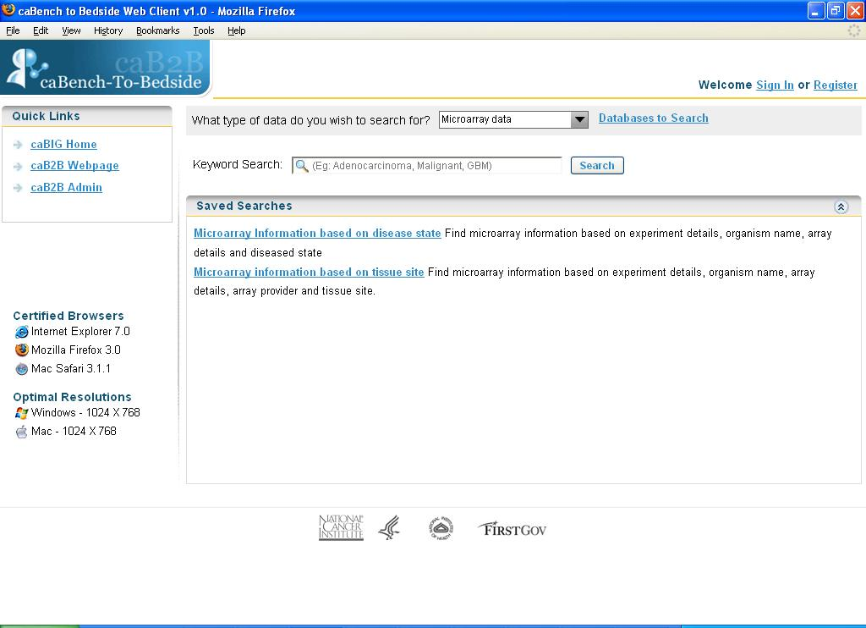
Figure 1.1 Home Page
As detailed above, the non-secure data can be queried without authentication, one of the non-secure data is selected by default and the queries for that data type are shown. The home page displays the following information:
- Sign In or Register
- Quick links
- What type of data do you wish to search for?
- Databases to Search
- Keyword Search
- Saved Search

Home Page
The links present on home page are as follows:
- Sign In or Register
To access the secure data you need to login to the caB2B with your production caGrid credentials. To login into the application, click the Sign In link at the top of the page (refer to Figure 1.1).
If you do not have grid credentials then you can click the Register link that will take you to the registration page.
- Quick links
Quick links refer to the caBIG® Home Page, caB2B Web Page and caB2B Administrative Module. You can navigate to these applications from caB2B Web Application.
- What type of data do you wish to search for?
The type of data are defined under the drop down for “What type of data you wish to search for?” where you can simply select the data type and the queries for the same data type are displayed in the saved searches
You need to select the type of data that you want to search. The administrator using the administrative module would define the types of data you can search for
.
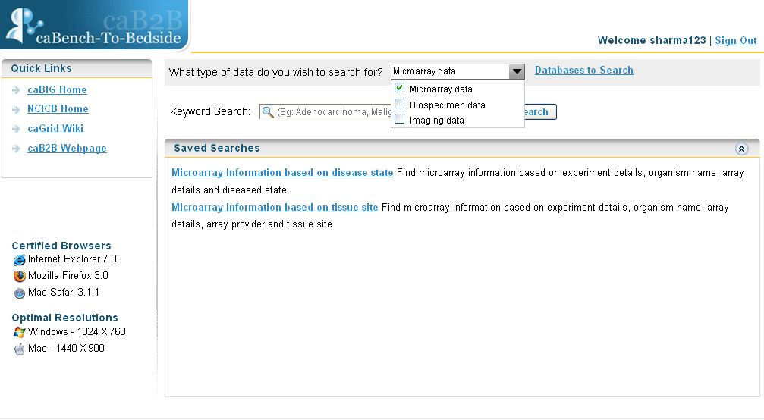
Select model group
Figure 1.2 Home page showing types of data
- Databases to Search
For databases to search, refer to Databases to Search
- Keyword Search
The keyword search is for a user who wants to know what kind of data is available on the caGrid. You just need to provide a word/s to get back the results.
- Saved Search
The saved searches are for finding data in a more systematic way where you will be providing more specific search criteria. For specific results, you need to set conditions on a set of limits.

Types of User
The application supports two user roles – Anonymous User and Grid User. You can search for data without actually signing in, although only publically available data is available. All such users who are querying for data without actually signing in are Anonymous Users.
The other type of user is Grid User. These users are the ones who sign into the application using their production caGrid credentials. To sign into the application follow the steps given below:
- Click on the Sign In link, at the top right hand corner on the Home Page.
- Enter User Name and Password (refer to Login page).
- Click Login.
- If you make an error while entering data click Reset, to clear the fields.
- To return to Home page click Home.

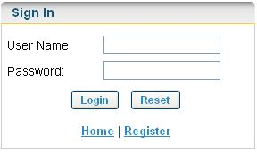
Figure 1.3 Login page
If you do not have a production caGrid account then click on the Register link on either the Home page or the Login page. This will navigate you to the caGrid registration page. You can create a user account from here.

Understanding Queries and Limits
Queries and limits form the basis of the web application. Queries fetch data from various biological applications. The limits set on the queries decide the result.

What is a Limit?
A limit is a condition (or criterion or predicate or condition) on a category. It is the smallest unit of a query. For example, female participants

What is a Query?
The collection of limits is a query. For example, female participants who have DNA specimens collected from their breast. This query has two limits: female participants, DNA specimens from breast.

 | Administrator creates the saved-search and the keyword queries using caB2B thick client.

Application Workflow
The general workflow within the application follows the steps outlined below:
- Access the caB2B web application home page.
- Login if you want to query a secured data service.
- Select type of data from What type of data do you wish to search for?
- Enter a keyword for keyword search and execute (Chapter 3 Keyword Search).
- Select a saved search, define a limit and execute the saved search (refer to Chapter 4 Saved Searches).
- Navigate to the results page.
- Results can be exported in desired format (excel, csv, pdf).

How caB2B Web Application differs from caB2B Client Application?

caB2B Web Application is an easy to use tool that is accessible to users over the web and does not require any download and installation. caB2B Web Application allows users to perform predefined queries to retrieve microarray data (caArray), image data (NBIA) and biospecimen data (caTissue Core) across caGrid without needing to understand how the data is stored. Users do not need to rely on understanding of domain models for the caBIG® applications. Administrator defined queries based on common use cases are available for users to execute. User can perform either a keyword search or a saved search (parameterized query). Users can export the results retrieved for future reference and analysis
caB2B Client Application, on the other hand, is a java based desktop client application that needs to be downloaded and installed. Advanced users with knowledge of caBIG® applications and their domain models can create and save custom queries which can be accessed either through the client or the web application. You can create the queries and execute them for any caGrid data services. You can also save the results returned in the form of a 'virtual experiment'. These data can be visualized using various graphical components

Databases to Search
This chapter describes the role of caB2B Web Application in configuring the hosting institutions from where you want to fetch data.
This chapter contains the following topics:
- Introduction
- Configuring Hosting Institutions

Introduction
“Databases to search” lists the various hosting institutions where the data for selected type is available, for example if you select Microarray data then you can view the hosting institutions where the microarray data is available. You can see the hosting institution name and description (service URL, description).
You can select multiple hosting institutions to query for selected type of data For example, if the user selects the type of data as “Microarray Data” and selects the Washington University School of Medicine and the National Cancer Institute Center for Bioinformatics hosting institutions, the application will fetch data from both these institutions.
The administrator configures the services, but if you want to fetch data from a particular hosting institution, which the administrator has not configured, then you can click on the Databases to Search and save new hosting institutions.

Configuring Hosting Institutions
To configure the hosting institutions for selected type of data follow the steps given below:
The steps to configure service instances:

- Select type of data (e.g. Microarray data) from the “What type of data do you wish to search for?” drop down.
- Click Databases to Search.

Figure 2.4 Databases to search link on home page

- Application will show the hosting institutions available for the selected type of data, for example microarray data.
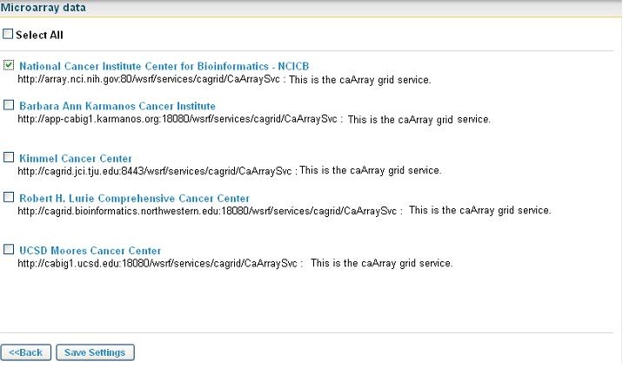
Admin defined Instance

Figure 2.5 Hosting institutions for microarray data
- The administrator defined hosting institutions are displayed as already selected (refer Figure 2.5)

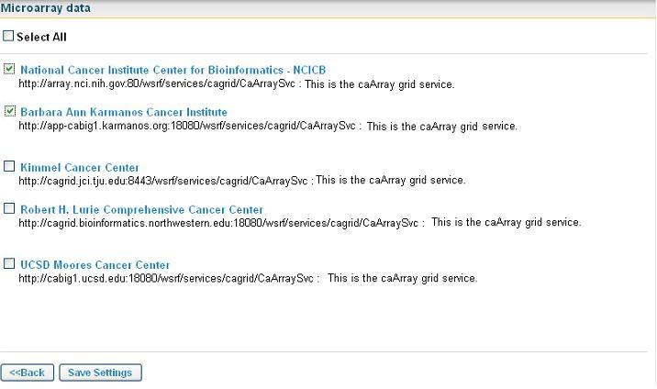
- To configure hosting institutions, select the check boxes for the hosting institutions from where you wish to fetch the data.
Figure 2.6 Select Hosting Institutions
To select or deselect all the institutes click Select All check box.

- Click Save Settings to save the hosting institutions.

Figure 2.7 Save Settings

- If you do not want to change the settings then click Back to return back to the Home page (Figure 2.7)

If the user has not signed in then when the user closes the application the hosting institutions saved are lost. Next time when the user accesses the application, the settings might have changed.
If the user signs into the application, then the hosting institution changes are not lost. Next time s/he signs in again, the previous settings are available.

Keyword Search
This chapter describes how caB2B Web Application can be used to fetch data using a keyword from caGrid data services like caArray, NBIA, caTissue etc.
This chapter contains the following topics:
- Introduction
- Search Data
- View Results
- Export ResultsError: Reference source not found

Introduction
Keyword search is for a user, who does not know what data is available on caGrid. It is a simple keyword based search where results are fetched based on the word that you entered. The keyword can be any word representing a disease name or an organ name or specimen type etc. depending on the type of data you want to search. The hosting institutions queried are the ones that you have defined. If the user did not define any hosting institutions then the administrator-defined instances are queried.
For example if you want to search for all the Microarray data available for a particular disease “Glioblastoma multiforme (GBM)” then you can enter a keyword as “GBM” or “Glioblastoma multiforme” which will return all the microarray experiments that have been done using a sample collected form a patient suffering from GBM.

Search Data
Keyword search is the simplest type of search available for getting data. To search data using keyword search follow the steps given below:
- Select the type of data from the dropdown “What type of data do you wish to search for?” (refer to Home Page)
- Configure hosting institutions from Databases to Search (refer to Databases to Search)
- Type the search string in the text box next to keyword search. For example, type in GBM

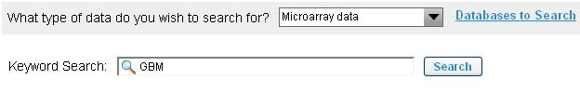

Enter keyword

Figure 3.8 Enter search string

  - Click Search.

Figure 3.9 Click on Search to execute query

- Results that match the given search term are displayed in the result view.

Two words separated by a space are treated with an AND operator in between for example, if user specified “GBM Lung” then it would be treated as a single term while querying.

View Results
Keyword search executes one or more queries on the configured hosting institutions. The results are retrieved from the configured hosting institutions. The results obtained from the execution of keyword search are displayed in a spreadsheet. One result spreadsheet is displayed for each query. The figure below shows the result spreadsheet. The result is for a query: “Microarray information based on tissue site”.
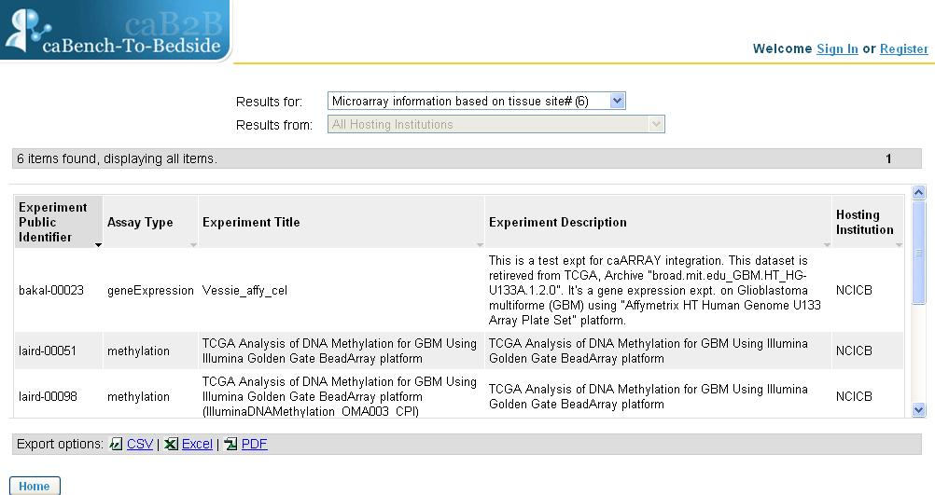
Figure 3.10 Results for key word query
You can change the query from the Result for dropdown and view the results for another query. The dropdown shows the count of result obtained from the query along with the query name.

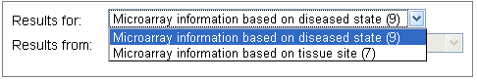

Figure 3.11 Dropdown showing different queries with the result count

Export Results
User can export the results in excel, csv (comma separated format) or pdf format for further use. The exported results contains additional information about the hosting research center e.g. hosting cancer centre full name and the point of contact and email address for the data service from which results were retrieved.
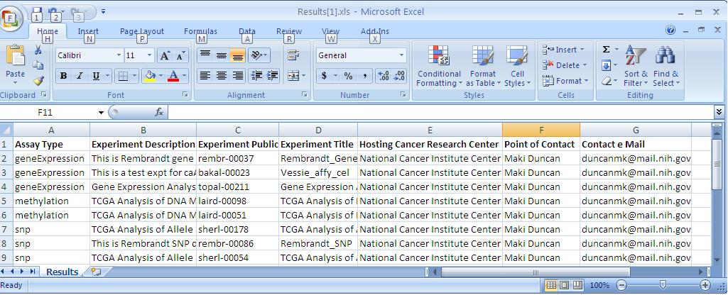
Figure 3.12 Exported results for Microarray data for Keyword Search

Saved Searches
This chapter describes the saved searches available in the web application. The administrator defines the saved searched for a particular type of data (Biospecimen data, Microarray data etc). The Saved Searches panel on the home page displays the saved searches.
The results of these searches represent most important information that each type of data represent. (For example, the search would help us to find information about Tissue Specimens or Molecular Specimens with specific characteristics from the Biospecimen data).
Saved searches consist of a set of limits (like assay type, organism etc) where you can put a condition according to the data to be fetched. This helps you to get more relevant results and better performance. For example, if you want to get the microarray information for “Glioblastoma multiforme” then open the saved searches for microarray data and type in the condition for disease state as “Glioblastoma multiforme”. This will return all the microarray experiments performed with samples collected from patients suffering from “Glioblastoma multiforme”.
This chapter contains the following topics:
- Define Limits
- View search Results
- Export Results

Define Limits
Define limits page appears when you select a saved search from the home page. The define limit page consist of limits on which you can put a condition according to the data you want to fetch. Some attributes contain a fixed set of values called as the permissible values that you can select to define a condition.
Follow the steps given below to define limit and execute a saved search:
- Select a model group from the dropdown on home page and click on a saved search (for example: Microarray Information based on diseased state)
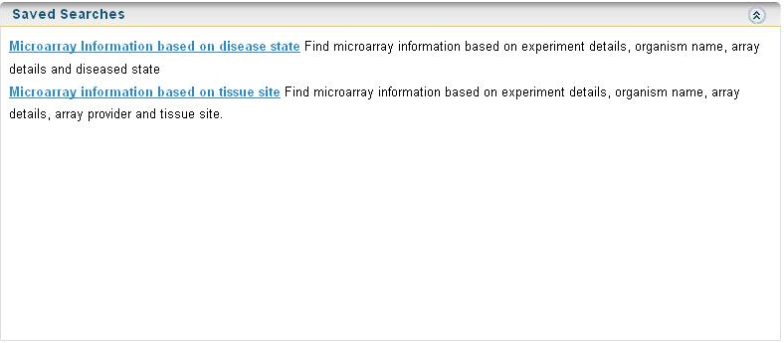
Figure 4.13 Saved searches for Microarray data
- Define limits page appears.
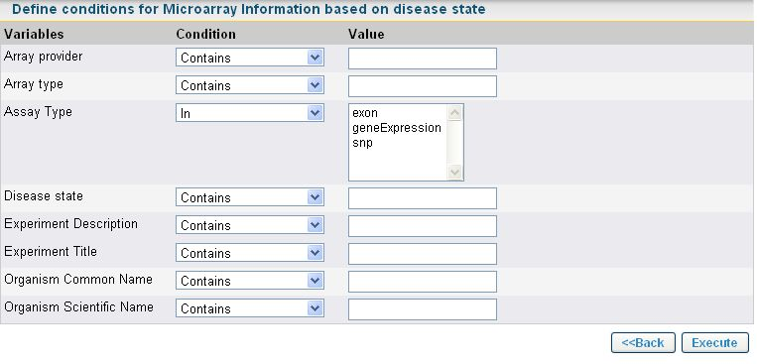
Figure 4.14 Define Limit page

- Add a condition to any limit based on which you want to fetch data.
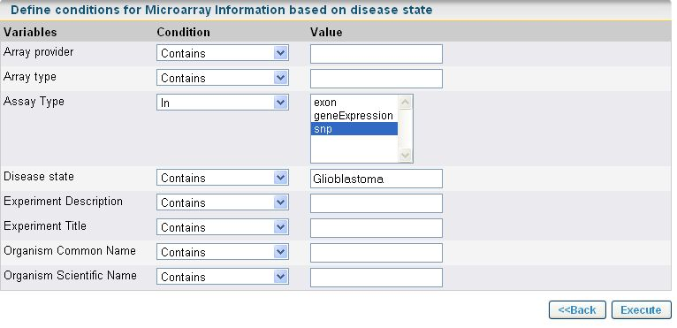
Figure 4.15 Define Limit
- Click Execute.
- Results are fetched based on the limits defined.

View search Results

The results page of the saved searches is updated dynamically. The user does not need wait for the completion of the query to view the results. The user can view the results as soon as data comes back from the service. The results page has a limit of 100 records. If there are more than hundred records then the query is executed offline and the status is shown as “query is in progress”. When the query is complete then the user can export complete set of results by clicking Export All button.

While the query is in progress the Export All button is disabled. It is enabled when the query execution is complete.

Figure below shows the result page of the saved search.
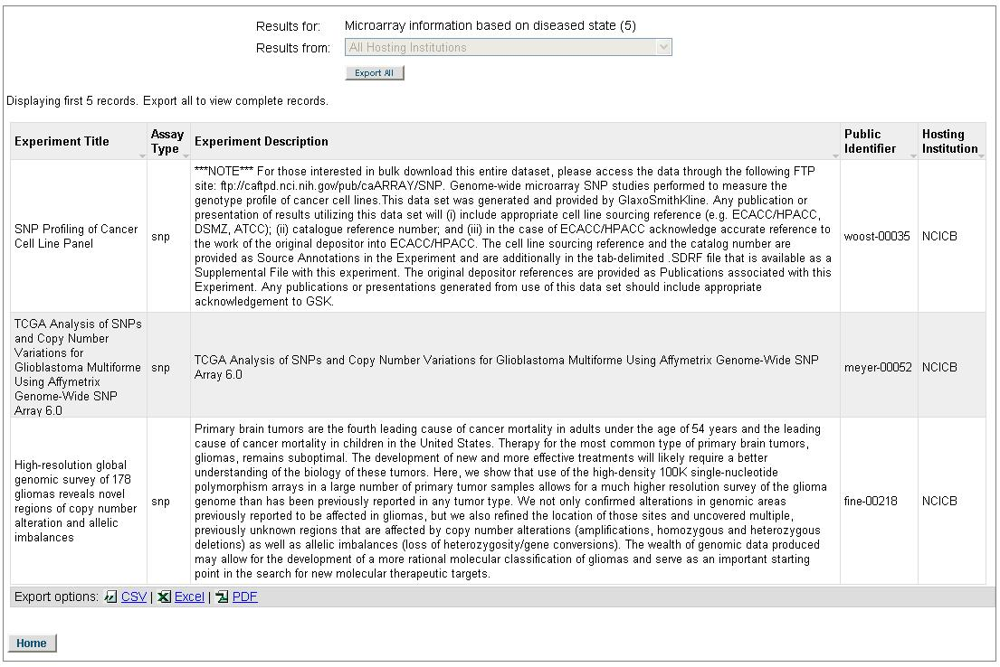
Export options for results
Go back to home page
Export all results
Figure 4.16 Results spread sheet for saved query

Export Results
There are two ways to export the results obtained from the saved searches:
- Export results displayed on results page.
You can export the results that are displayed on the results page by using the export options at the bottom of the spreadsheet. You can export the results in csv, excel or pdf format.
- Export all the results when the query is completed.
You can export all the results once the query is complete by clicking Export All. As the limit of results page is of one hundred results so if the query returns more than one hundred results you cannot view them on the results page, but you can export the results in csv format with the help of Export All option.

If you select a permissible value of an attribute and you want to deselect, then press CTRL + click on permissible value to deselect.

Error Messages/Indicators and Problem Resolutions
This chapter includes certain error messages and their solution:
- Access secure data
- Invalid login credentials
- Failed Hosting Institutions

Access secure data
To access secure data you need to have valid caGrid production credentials and sign in using them. You can access such data only when you are signed in. For example, in figure below, Biospecimen data is secure data. If you try to select Biospecimen data, it gives a message asking you to sign in.

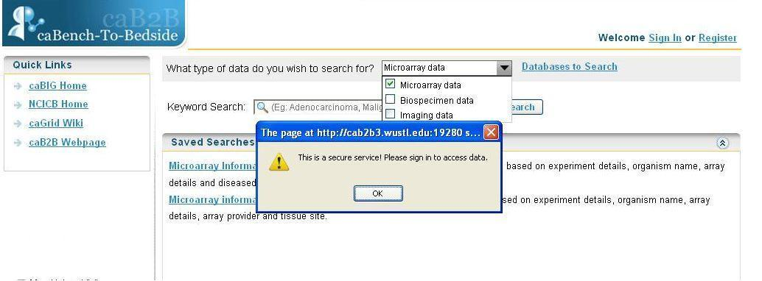
Figure 5.17 Error message on accessing secure data

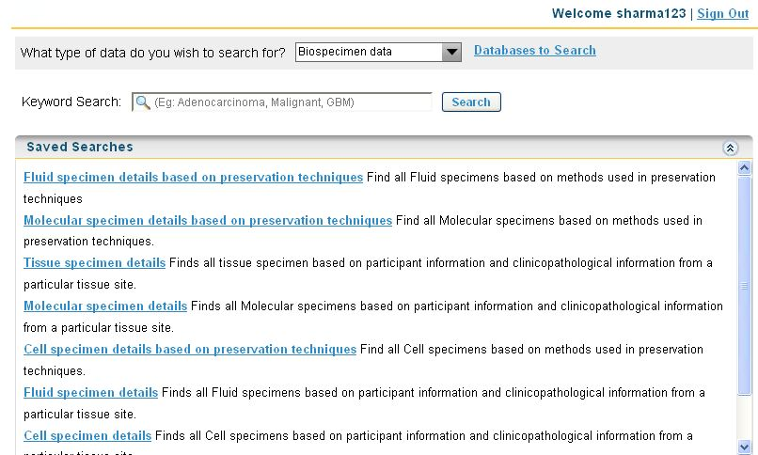
Figure 5.18 Secure service accessible after signing in

Invalid login credentials

caB2B Web Application gives error if invalid grid credentials are used to login .

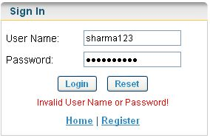
Figure 5.19 Invalid grid credentials error message

Failed Hosting Institutions

caB2B web application allows to configure the hosting institution from where you wish to search data (refer to Chapter 2Databases to Search). If the application is unable to fetch data from one of the configured hosting institutions then, the application show an error message. On the results page along with the results from successfully queried instances all the instances that failed to return results are also displayed as "Failed Hosting Institutions".
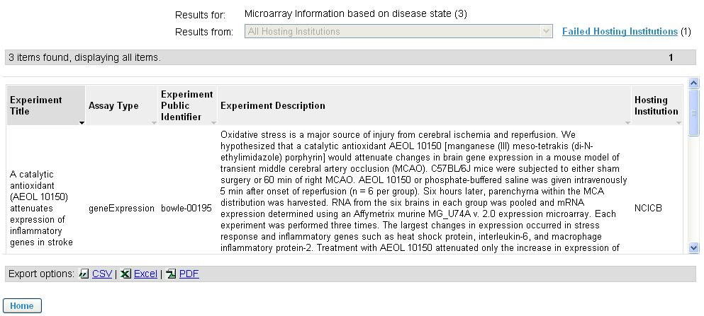
Figure 5.20 Failed hosting institution and its count

You can view which institution did not fetch results by clicking on Failed Hosting Institutions.
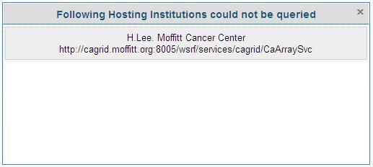
Figure 5.21 Failed Hosting Institution
For future queries, you can go to the Databases to Search page and remove the hosting institution, which could not be queried.
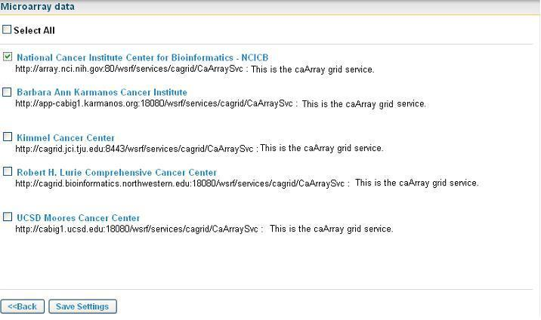
Figure 5.22 Deselect failed hosting institution
Then execute the query.

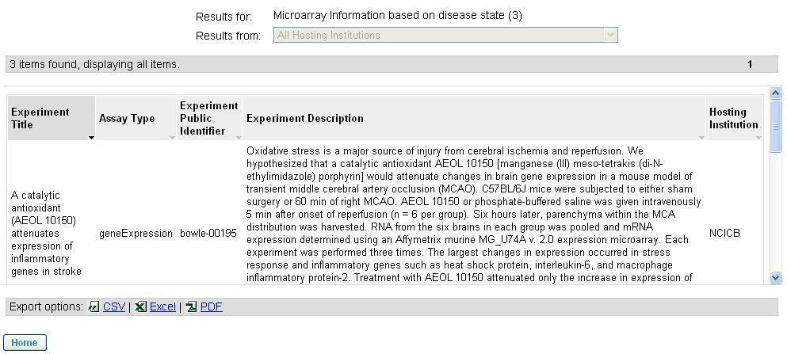

Figure 5.23 Results Page

Example for searching data
This appendix provides example of searching data:
- Keyword Search
- Saved Searches

Keyword Search

Example: Find microarray data for “Glioblastoma”
Before you can execute a keyword query administrator needs to configure the application. Administrator should follow the steps below to create a keyword search:
- Administrator will configure the application by doing the following in the administrative module:
  - Load Model - Load a version of caArray model
  - Service Instances - Configure the institutes to be searched
  - Define Model Group – Define a model group Microarray data for the model loaded.
  - Create Category – Create a category for the query.
- Administrator will then launch the caB2B Client Application and save the Keyword Query (refer to caB2B Client Application end user manual for steps to save a query).

Once the administrator has done the configuration, you can now see the queries in the Web Application. Now you can execute the queries by following the steps given below:
- Select Microarray data from What type of data do you wish to search for? dropdown
Figure A. 1 Select model group
- Click Databases to search (refer to Figure A. 1) and select National Cancer Institute Center for Bioinformatics - NCICB for query.
Figure A. 2 Select NCICB instance
- Click Save Settings.
Figure A. 3 Save Settings
- In the Keyword Search text box, enter Glioblastoma.


Figure A. 4 Enter keyword
- Click Search (refer to Figure A.4).

- Navigate to the results page to view the results.
Figure A. 5 Result page for keyword query
- Change the query in the Results for dropdown to view the results for another query
Figure A. 6 Dropdown to change the query

- Click on the Identifier column header to sort the results.

- Click on Excel icon to export the results in excel sheet.
Figure A. 7 Results exported in excel sheet

Saved Searches

Example: Find Microarray data for “Glioblastoma” where assay type is “SNP”
Follow the steps given below to execute a saved search:

Before a you can execute a saved search administrator needs to configure the application. Administrator should follow the steps below to create a saved search:
- Administrator will configure the application by doing the following in the administrative module:
  - Load Model - Load a version of caArray model
  - Service Instances - Configure the institutes to be searched
  - Define Model Group – Define a model group Microarray data for the model loaded.
  - Create Category – Create a category for the query.
- Administrator will then launch the caB2B Client Application and save the Query (refer to caB2B Client Application end user manual for steps to save a query).

Once the administrator has done the configuration, you can see the queries in the Web Application. Now you can execute the queries by following the steps given below:

- Select Microarray data from What type of data do you wish to search for? dropdown(refer to Figure A. 1)
- Click on Databases to Search and select National Cancer Institute Center for Bioinformatics - NCICB for query.(refer to Figure A. 2)
- Click Save Settings (refer to Figure A. 3)
- Click on Microarray information based on disease state from the saved searches box.
Figure A. 8 Click on saved search
- Navigate to the Define Limits page.
Figure A. 9 Define limit page
- Define limit on Assay Type as SNP and Disease State as Glioblastoma
Figure A. 10 Add condition and execute query
- Click Execute.
- Navigate to the Results page.

Figure A. 11 Result page
- Sort the results by clicking on Identifier.
- Click on Excel icon to export the results in excel sheet(refer to Figure A. 11)

Index

A
Add limits, 19
C
caB2B, 3
caB2B admin module, 4
caBIG, 1, 3, 6
caBIG®, 3
caGrid, 3, 15
D
Databases to search, 11
Define limits, 20
E
export, 1, 3, 17, 30, 34
F
Failed Hosting Institutions, 25
L
Limits
definition, 7
login, 6, 23, 24
M
model group, 19, 27, 28, 31
Model group, 6
N
NCI, 3
Q
Query
definition, 8
Query Wizard, 15, 16, 18
R
register, 6
S
save settings, 14, 28, 32
Saved searches, 19
service instances, 11
sort, 30
T
translational research, 1
V
View search Results, 21

